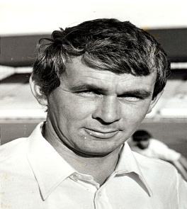

William Allen Thomson

4 August 1943---22 October 2019

Bill Thomson gave great service to the Sydenham cricket club joining in 1960 at the age of 17 until his final season in 2004. For the premier team he played 238 matches from 1961 until 1984 and in 397 innings he scored 9,400 runs at an average of 24.50, including 33 half centuries, nine centuries and 110 catches. Bill was an aggressive, dashing left hand batsman who played all the shots, always intent on making a statement to the bowlers. He exceeded over 400 runs in a season no fewer than thirteen times and 300 runs four times. Including all matches for the club, Bill scored over 14,000 runs, a record that few other batsmen will better.

fHe was selected to play for Canterbury in the Brabin Under 20 tournament on three occasions from the 1960/61 season scoring 33 and 67 in his first match against Wellington at the University Oval in Dunedin. He continued in fine form with 34 and 41 against Auckland. The following year he had scores of 89 against Auckland and 64 against Wellington. Clearly showing much promise Bill competed in three Under 23 tournaments with scores of 61 against Otago and 98 against Northern Districts in the 1964/65 tournament. Following his success at this tournament he was selected to play for the New Zealand Under 23 team in a three day match against Canterbury. However the New Zealand XL was outclassed by Canterbury who won the game in two days by an innings and 158 runs.

In spite of his success at club and under age tournaments, it was not until 30 December 1974 and at the age of 31 that he made his Canterbury debut which was against Auckland at Lancaster Park. Canterbury won the toss and sent Auckland into bat and they had scored 351 for the loss of nine wickets when the declaration was made. Bill opened the batting with Murray Parker but the two openers were dismissed early and Canterbury struggled to reach 166. Following on Canterbury had a much better response and the openers put on 96 in 128 minutes with Bill contributing 55 with one 6 and eight fours. Canterbury made 360 and dismissing Auckland for 149 Canterbury went on to win by 26 runs

He was made a life member of the Sydenham club in 1992 in recognition of his services to the club.